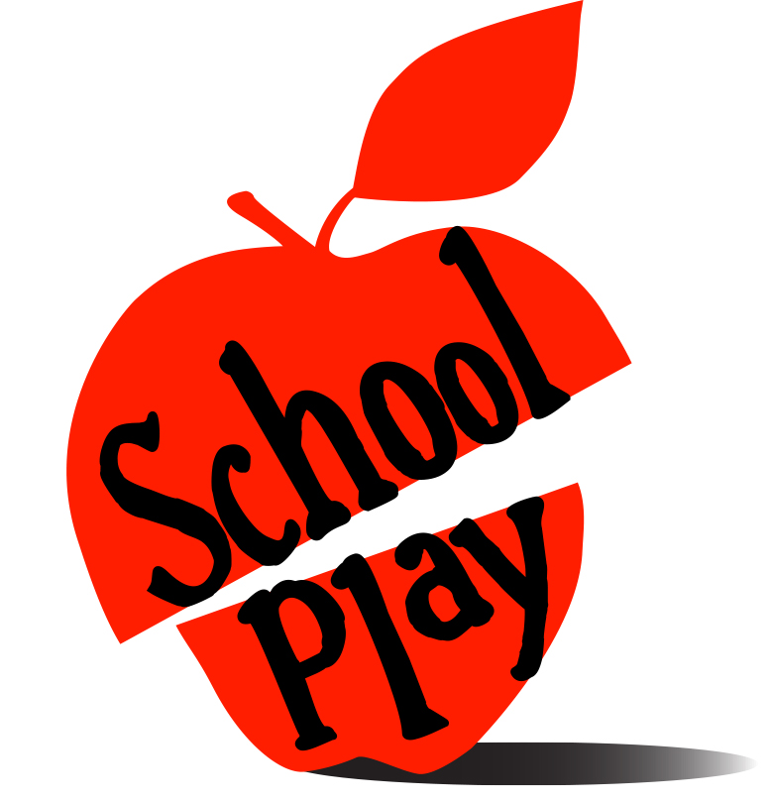
It’s a tough subject.
A live theatre collaboration between
playwrights Arden Kass and Seth Bauer and director Edward Sobel
and Public Citizens for Children & Youth
Presented by *Name of your Group*
School Play explores our attitudes
toward public education using the real voices of
Pennsylvanians from across the Commonwealth.
*Your Performance Dates and Times*
*Your Performance Location and Address*
*Your Reservation Information*
*Email, website, phone*
YOUR LOGO HERE

